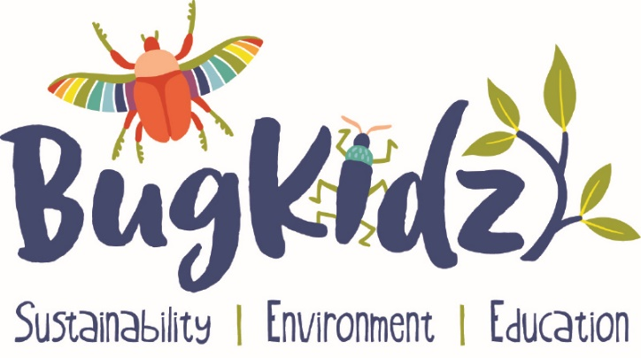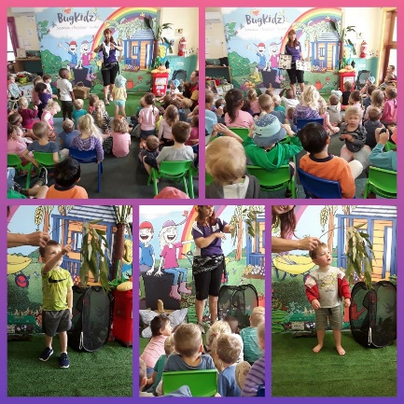

Bug Kidz at your next Event

A delightful and fascinating journey into the world of
Australian insects

Entertain - Amaze and fascinate the children with this interactive, theatrical show. The Bug Kidz Insect Show is musical and set against a large colourful backdrop to imitate a garden scene. A great way to develop an understanding about the important roles insects play in the garden, their environmental significance, lifecycles, and how to stay safe whilst being outdoors.

An educational storyline with a cast of puppets to take you on a fun fact filled expedition into the intriguing world of these amazing Australian creatures!

To support the performance there are tables of live and displayed insects. After the show children can walk by to admire or have an opportunity to interact with some of these amazing insects. Great photo opportunities. The Bug Kidz Insect show is captivating and exciting, engaging for children of all ages.

The Show Comes to You

Fully self-contained with professional music, sound, backdrop and props - so everyone can join in or just sit back and enjoy the show!

Please contact Lea for bookings, pricing and further information

W bugkidz.com.au P 0438 199245 E info@bugkidz.com.au
Fb Find us on Facebook abn 521 686 21274
Sustainability I Environment I Education

