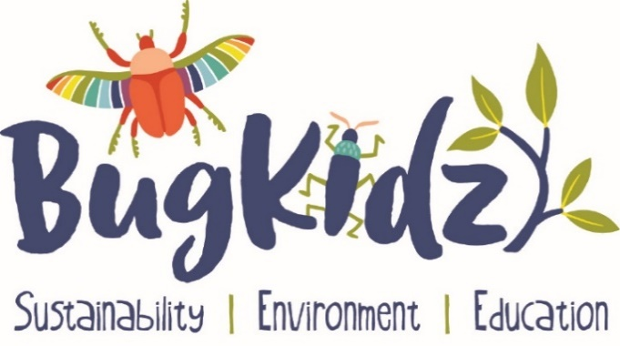

Bug Kidz for Schools

A delightful and fascinating journey into the world of Insects

An informative show which can help the children to develop a deeper understanding of the important roles that mini beasts play in our lives every day.
Insects are vital to our world’s existence.

Prep & Year 1: An interactive theatrical puppet show set against a colourful backdrop, with professional sound recordings, songs and props. During this storyline the children can learn some fun bug facts as they are entertained. This is a fun introduction into the insect world.

After the show; there are 3 interactive Bug Stations which the children have a choice to view magnificent live and preserved insects. Get close and personal with hands on experiences or simply admire from afar. There are no dangers here. This is a great opportunity to connect with nature and to learn a little more about these fascinating creatures.

Additionally we will be learning the concepts of worm farming and composting. There is an opportunity to buy a fully functional worm farm bucket which can be added to your invoice. A container with dry grass is all you need to compost in your classroom. What a great way to see more bugs. I can easily show you how these can be implemented into your everyday routines, and I am always available through email support or FB messenger.

Please contact Lea for bookings, pricing and further information

W bugkidz.com.au P 0438 199245 E info@bugkidz.com.au
Fb Find us on Facebook abn 521 686 21274
Sustainability I Environment I Education

